Task 1

1. Max, min, summary sales by December 2000, Internet and Direct Sales, All States

SELECT CASE

WHEN GROUPING_ID (TIMES.CALENDAR_MONTH_DESC,CHANNELS.CHANNEL_DESC,COUNTRIES.COUNTRY_NAME) = 7

THEN 'GRAND TOTAL'

ELSE TIMES.CALENDAR_MONTH_DESC

END YEAR_MONTH,

CASE

WHEN GROUPING_ID (TIMES.CALENDAR_MONTH_DESC,CHANNELS.CHANNEL_DESC,COUNTRIES.COUNTRY_NAME) = 3

THEN 'Total by Channels'

ELSE CHANNELS.CHANNEL_DESC

END CHANNEL,

CASE

WHEN GROUPING_ID (TIMES.CALENDAR_MONTH_DESC,CHANNELS.CHANNEL_DESC,COUNTRIES.COUNTRY_NAME) = 1

THEN CHANNELS.CHANNEL_DESC || ' Total by Sales'

ELSE COUNTRIES.COUNTRY_NAME

END COUNTRY,

TO_CHAR(MAX(AMOUNT_SOLD),'9,999') "MAX_SALES$",

TO_CHAR(MIN(AMOUNT_SOLD),'9,999') "MIN_SALES$",

TO_CHAR(SUM(AMOUNT_SOLD),'9,999,999') "SALES$"

FROM TIMES, SALES, CHANNELS, COUNTRIES, CUSTOMERS

WHERE SALES.TIME_ID=TIMES.TIME_ID and SALES.CUST_ID=CUSTOMERS.CUST_ID and

SALES.CHANNEL_ID=CHANNELS.CHANNEL_ID and TIMES.CALENDAR_MONTH_DESC='2000-12' and

CHANNELS.CHANNEL_DESC in ('Internet', 'Direct Sales') and CUSTOMERS.COUNTRY_ID=COUNTRIES.COUNTRY_ID

GROUP BY ROLLUP (TIMES.CALENDAR_MONTH_DESC, CHANNELS.CHANNEL_DESC, COUNTRIES.COUNTRY_NAME);

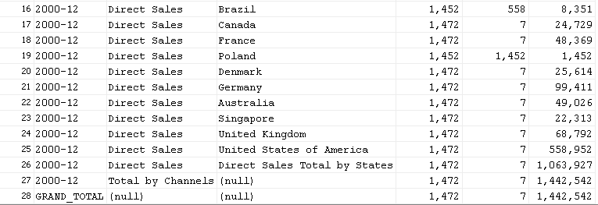

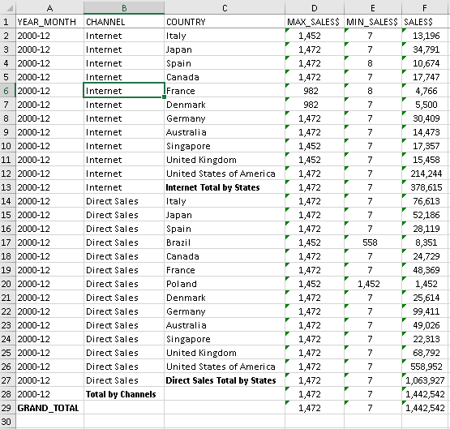

1. Sales in Asia from Photo category by 2000 year by quarter(TOTAL & SUM)

SELECT NVL(PROD_NAME,'TOTAL') AS PRODUCT_NAME, SUM(Q1) AS Q1, SUM(Q2) AS Q2, SUM(Q3) AS Q3,

SUM(Q4) AS Q4, SUM(YEAR_SUM) AS YEAR_SUM

FROM

(SELECT DISTINCT PRODUCTS.PROD_NAME,

NTH_VALUE(SUM(AMOUNT_SOLD),1) OVER (PARTITION BY PRODUCTS.PROD_NAME ORDER BY TIMES.CALENDAR_QUARTER_NUMBER ASC RANGE BETWEEN UNBOUNDED PRECEDING AND UNBOUNDED FOLLOWING) AS Q1,

NTH_VALUE(SUM(AMOUNT_SOLD),2) OVER (PARTITION BY PRODUCTS.PROD_NAME ORDER BY TIMES.CALENDAR_QUARTER_NUMBER ASC RANGE BETWEEN UNBOUNDED PRECEDING AND UNBOUNDED FOLLOWING) AS Q2,

NTH_VALUE(SUM(AMOUNT_SOLD),3) OVER (PARTITION BY PRODUCTS.PROD_NAME ORDER BY TIMES.CALENDAR_QUARTER_NUMBER ASC RANGE BETWEEN UNBOUNDED PRECEDING AND UNBOUNDED FOLLOWING) AS Q3,

NTH_VALUE(SUM(AMOUNT_SOLD),4) OVER (PARTITION BY PRODUCTS.PROD_NAME ORDER BY TIMES.CALENDAR_QUARTER_NUMBER ASC RANGE BETWEEN UNBOUNDED PRECEDING AND UNBOUNDED FOLLOWING) AS Q4,

SUM(SUM(AMOUNT_SOLD)) OVER (PARTITION BY PRODUCTS.PROD_NAME) AS YEAR_SUM

FROM PRODUCTS, TIMES, SALES, COUNTRIES, CUSTOMERS

WHERE SALES.TIME_ID=TIMES.TIME_ID and SALES.CUST_ID=CUSTOMERS.CUST_ID and

SALES.PROD_ID=PRODUCTS.PROD_ID and CUSTOMERS.COUNTRY_ID=COUNTRIES.COUNTRY_ID and

PRODUCTS.PROD_CATEGORY='Photo' and TIMES.CALENDAR_YEAR=2000 and COUNTRIES.COUNTRY_SUBREGION='Asia'

GROUP BY PRODUCTS.PROD_NAME, TIMES.CALENDAR_QUARTER_NUMBER)

GROUP BY ROLLUP(PROD_NAME);

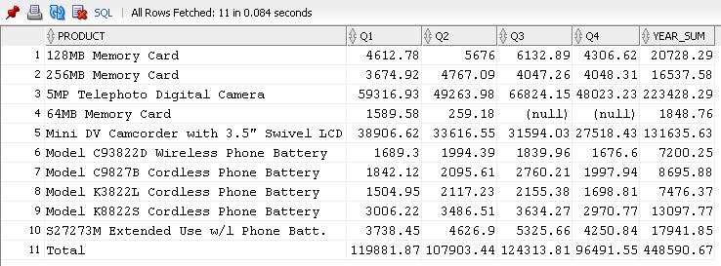

1. PIVOT

SELECT * FROM

(SELECT COUNTRIES.COUNTRY_REGION, PRODUCTS.PROD_CATEGORY, AMOUNT_SOLD

FROM PRODUCTS, TIMES, SALES, COUNTRIES, CUSTOMERS

WHERE SALES.TIME_ID=TIMES.TIME_ID and SALES.CUST_ID=CUSTOMERS.CUST_ID and

SALES.PROD_ID=PRODUCTS.PROD_ID and CUSTOMERS.COUNTRY_ID=COUNTRIES.COUNTRY_ID)

PIVOT (SUM(AMOUNT_SOLD) AS SUMS

FOR (PROD_CATEGORY) IN (('Electronics') AS Electronics,

('Hardware') AS Hardware, Peripherals and Accessories') AS Peripherals_and_Accessories,

('Photo') AS Photo, ('Software/Other') AS Software_Other));

